Create an HTML page as shown below using ordered and nested ordered lists.
<!DOCTYPE html>
<html>
<head>
<title>Task 1</title>

</head>
<body>
<!-- Task 1-->
<fieldset>
<h1 align="center" > Web Site Outline</h1>
<ol>
<li>Home Page</li>
<li>Link Page</li>
<ol type="I">
<li>Links to Search Engines</li>
<li>Links to Information Site</li>
<ol type="A">
<li>News Site</li>
<ol type="i">
<li>TV based</li>
<ol type="a">
<li>CNN</li>
<li>Headline</li>
</ol>
</ol>
<li>Stock Site</li>
</ol>
<li>Links to Fun Site</li>
</ol>
<li>Contact Page</li>

</ol>
</fieldset>
</body>

</html>

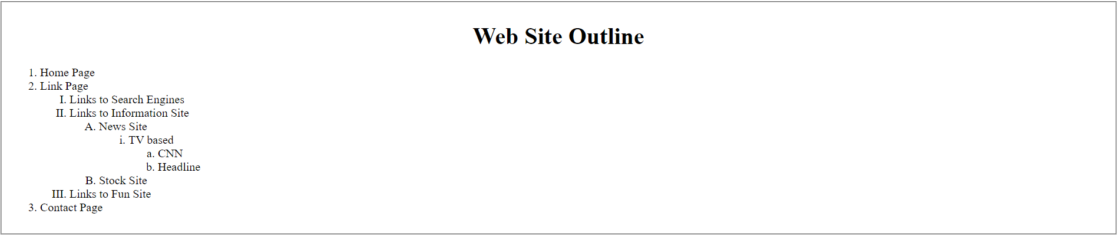

2. Create a login form as shown below:

<!DOCTYPE html>
<html>
<header>

</header>
<body>

<!--Task 2-->
<table border="0">
<tr >
<td colspan="2" align="left" >
<img src="G:\All Html projects\aa.jpg" width="200px" alt="image">
</td>
</tr>
<tr>
<td width="10%">UserName</td>
<td ><input type="text"></td>
</tr>
<tr>
<td >Password</td>
<td ><input type="password"></td>
</tr>
<tr>
<td colspan="2" ><button>Login</button>
<button>Cancel</button></td>
</tr>
<tr>
<td colspan="2"><input type="checkbox" name="" id=""> remember me</td>
</tr>
<tr>
<td colspan="2">Forgot <a href="">Password</a></td>
</tr>
</table>
</body>
</html>

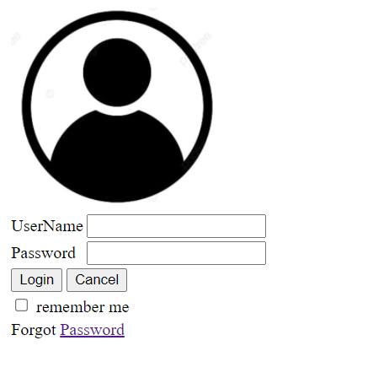

3. Create following tables using rowspan & colspan.

<!DOCTYPE html>
<html>
<header></header>
<body>
<!--Rowspan-->
<h2>rowspan</h2>
<table border="1" width="25%" cellspacing="2px" cellpadding="5px" >
<tr>
<td rowspan="3">
Users Info
</td>
<td>
1
</td>
<td>
John Carter
</td>
<td>
Johncarter@mail.com
</td>
</tr>
<tr>

<td>
2
</td>
<td>
Peter Parker
</td>
<td>
Peterparker@mail.com
</td>
</tr>
<tr>

<td>
3
</td>
<td>
John Rambo
</td>
<td>
johnrambo@mail.com
</td>
</tr>
</table>
<br>
<br>
<h2>Colspan</h2>
<!--Colspan-->
<table border="1" width="20%" cellspacing="2px" cellpadding="5px" >
<tr>
<td colspan="3">Users Info</td>
</tr>
<tr>
<td>1</td>
<td>John Carter</td>
<td>Johncarter@mail.com</td>
</tr>
<tr>
<td>2</td>
<td>Peter Parker</td>
<td>Peterparker@mail.com</td>
</tr>
<tr>
<td>3</td>
<td>John Rambo</td>
<td>johnrambo@mail.com</td>
</tr>

</table>

<br>
<br>

<p></p>
<table border="1" width="25%" cellspacing="10px" cellpadding="5px" >
<caption>fruit juice Drinks and Milks</caption>
<tr>
<td rowspan="2"></td> <td colspan="3">fruit juice Drinks</td>
</tr>
<tr>
<td>Apple</td>
<td>Orange</td>
<td>ScrewDriver</td>
</tr>
<tr>
<td>BreakFast</td>
<td>0</td>
<td>1</td>
<td>0</td>
</tr>
<tr>
<td>Lunch</td>
<td>1</td>
<td>0</td>
<td>0</td>

</tr>
<tr>
<td>Dinner</td>
<td>0</td>
<td>0</td>
<td>1</td>
</tr>
</table>

</body>
</html>

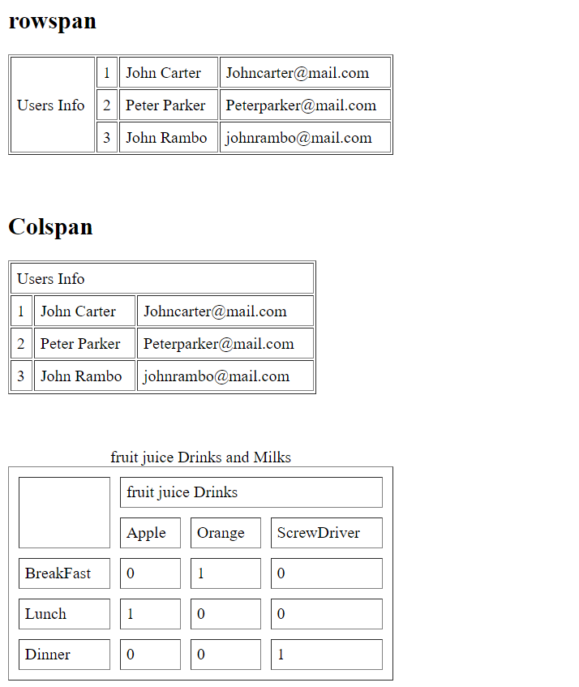

4. Create webpage about a recipe. Your page should have a description of the recipe, an image showing its output, list of ingredients, and steps/instructions to be followed in sequence to prepare that recipe.

<!DOCTYPE html>
<html>
<header>

</header>
<body>
<h3>To Die For Fettuccine Alfredo</h3>
<pre style="font-family:verdana">
This is a recipe that I created by modifying my mother's recipe.
My boyfriend is a fettuccine Alfredo connoisseur and he scrapes the pan every time!
I get nothing but rave reviews when I make this dish. I must warn you, this recipe is not for the health conscious. Enjoy!
<br>
<img src="image.png" alt="">
<h3>Ingredients</h3>
<input type="checkbox" name="" id=""> 1 cup butter
<input type="checkbox" name="" id=""> 24 ounces dry fettuccini pasta
<input type="checkbox" name="" id=""> ¾ pint heavy cream
<input type="checkbox" name="" id=""> salt and pepper to taste
<input type="checkbox" name="" id=""> 1 dash garlic salt
<input type="checkbox" name="" id=""> ½ cup grated Parmesan cheese
<h3>Instructions</h3>
<input type="checkbox" name="" id=""> Step# 1<br>
Bring a large pot of lightly salted water to a boil. Add fettuccini and cook for 8 to 10 minutes or until al dente; drain.
<input type="checkbox" name="" id=""> Step# 2<br>
In a large saucepan, melt butter into cream over low heat. Add salt, pepper and garlic salt. Stir in cheese over medium heat
until melted; this will thicken the sauce.
<input type="checkbox" name="" id=""> Step# 3<br>
Add pasta to sauce. Use enough of the pasta so that all of the sauce is used and the pasta is thoroughly coated. Serve immediately.

</pre>

</body>
</html>

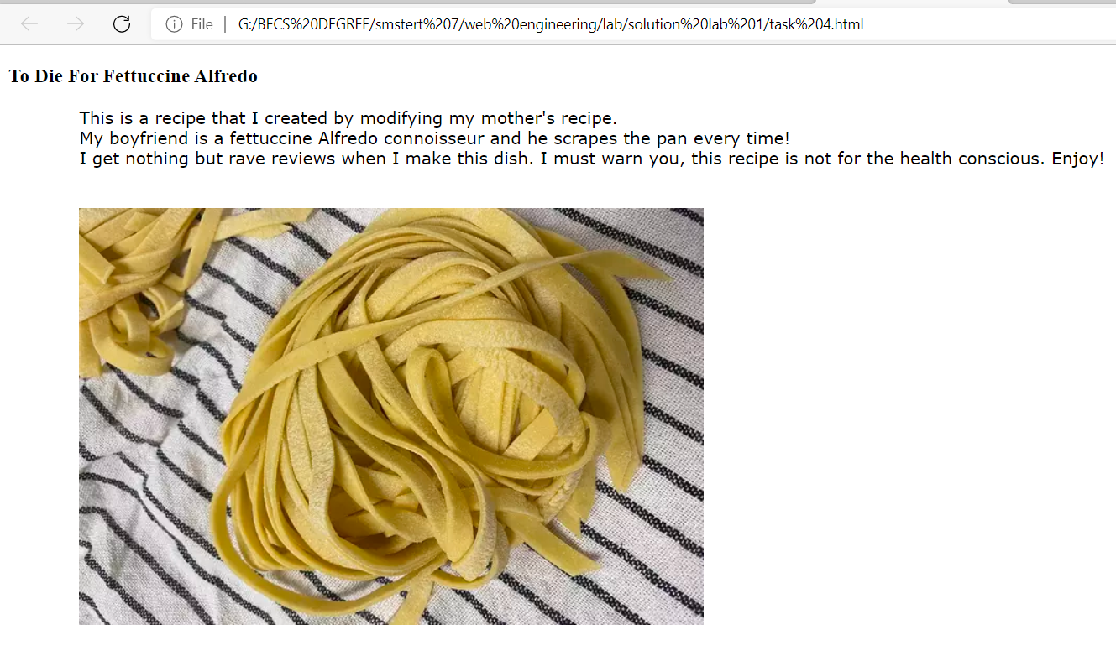
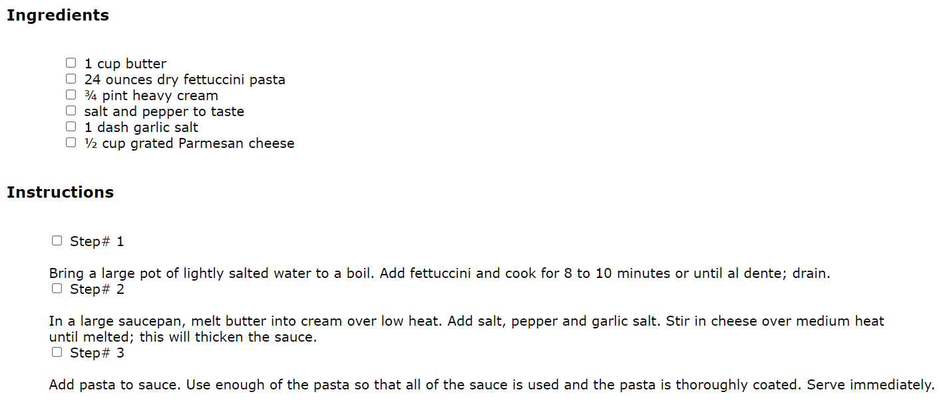

5. Create the following form using only HTML.

<!DOCTYPE html>
<html>
<header>

</header>
<body>
<h2>Welcome to millenium Gymnastic Booster Club Popcorn Sales</h2>
Buyer's Name: <input type="text"><br>
Street Address: <input type="text"><br>
City State zip: <input type="text">

<table width="20%">
<tr>
<td width="80%"><h3>Product Name</h3></td>
<td><h3>Price</h3></td>
<td ><h3>Quality</h3></td>

</tr>
<tr>
<td>Unpopped Popcorns(1 lb.)</td>
<td>$3.00</td>
<td><input size="1px" type="text"></td>
</tr>
<tr>
<td>caremal Popcorns(1 lb.)</td>
<td>$3.50</td>
<td><input size="1px" type="text"></td>
</tr>
<tr>
<td>caramal nut Popcorns(1 lb.)</td>
<td>$4.50</td>
<td><input size="1px" type="text"></td>
</tr>
<tr>
<td>Toffee nut Popcorns(1 lb.)</td>
<td>$5.00</td>
<td><input size="1px" type="text"></td>
</tr>
</table>

<H3>Payment Method</H3>
<input type="radio" value=""> Visa <br>
<input type="radio" value=""> MasterCard <br>
<input type="radio" value=""> Discover <br>
<input type="radio" value=""> Check <br><br>
<button type="submit">Submit Order</button>
<button type="reset">Clear Order form</button>

</body>
</html>

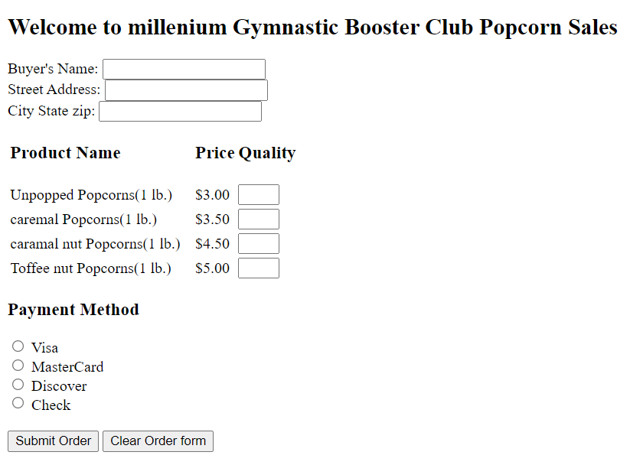
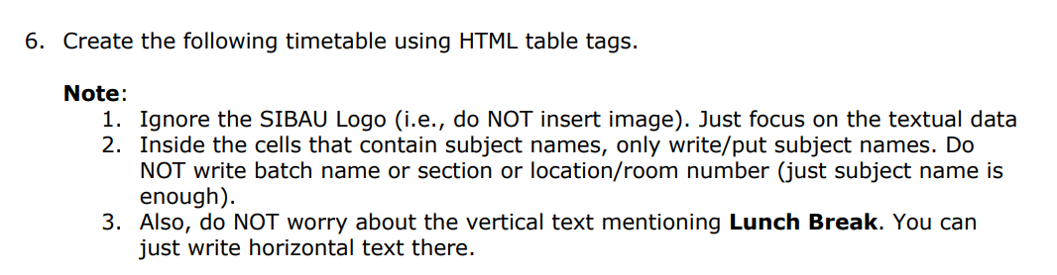

<!DOCTYPE html>
<html>
<header>

</header>
<body>
<h2 style="text-align: center;">Teacher Riaz Soomro</h2>
<table border="1" align="center"style="text-align: center;" width="80%" >
<caption>sukkur iba</caption>
<tr>
<td width="7%"></td>
<td width="7%"><h2>1</h2></td>
<td width="7%"><h2>2</h2></td>
<td width="7%" ><h2>Break</h2></td>
<td width="7%"><h2>3</h2></td>
<td width="7%"><h2>4</h2></td>
<td width="7%"><h2>Lunch time</h2></td>
<td width="7%"><h2>5</h2></td>
<td width="7%"><h2>6</h2></td>
<td width="7%"><h2>7</h2></td>
<td width="7%"><h2>8</h2></td>
<td width="7%"><h2>9</h2></td>
<td width="7%"><h2>10</h2></td>

</tr>
<tr>
<td><h2>Mo</h2></td>
<td></td>
<td></td>
<td rowspan="6" ></td>
<td></td>
<td ></td>
<td rowspan="6" style="writing-mode: vertical-lr;"> <h2>Lunch Break 30 minutes</h2></td>
<td></td>
<td></td>

<td colspan="2">Introduction to programming</td>
<td></td>
<td></td>

</tr>
<tr>
<td><h2>Tue</h2></td>
<td></td>
<td></td>
<td></td>
<td></td>
<td></td>
<td></td>
<td colspan="2">Introduction to programming</td>
<td></td>
<td></td>

</tr>
<tr>
<td><h2>Wed</h2></td>
<td colspan="2">Web Engineering-Lab</td>
<td>Web Engineering-Lab</td>
<td></td>
<td></td>
<td></td>
<td></td>
<td></td>
<td></td>
<td></td>

</tr>
<tr>
<td><h2>Thu</h2></td>
<td></td>
<td></td>
<td></td>
<td></td>
<td></td>
<td></td>
<td colspan="2">Introduction to programming</td>
<td></td>
<td></td>

</tr>
<tr>
<td><h2>Fri</h2></td>
<td></td>
<td></td>
<td></td>
<td></td>
<td></td>
<td></td>
<td></td>
<td colspan="2">Introduction to programming</td>
<td></td>

</tr>
<tr>
<td><h2>Sat</h2></td>
<td></td>
<td></td>
<td colspan="2">Web Engineering-Lab</td>
<td>Web Engineering-Lab</td>
<td></td>
<td></td>
<td></td>
<td></td>
<td></td>

</tr>

</table>
</body>
</html>

